**KN - k=2, variable mu and n**

**N = [1000, 5000, 10000]**

**Mu = 0 : 0.5 : 2**

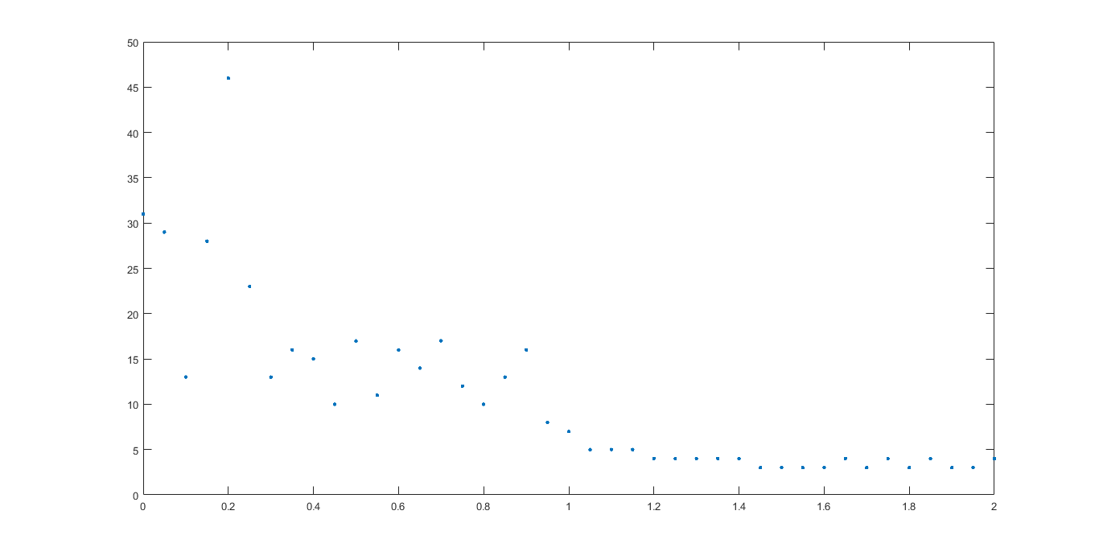

Figure : n = 1000, mu vs iters

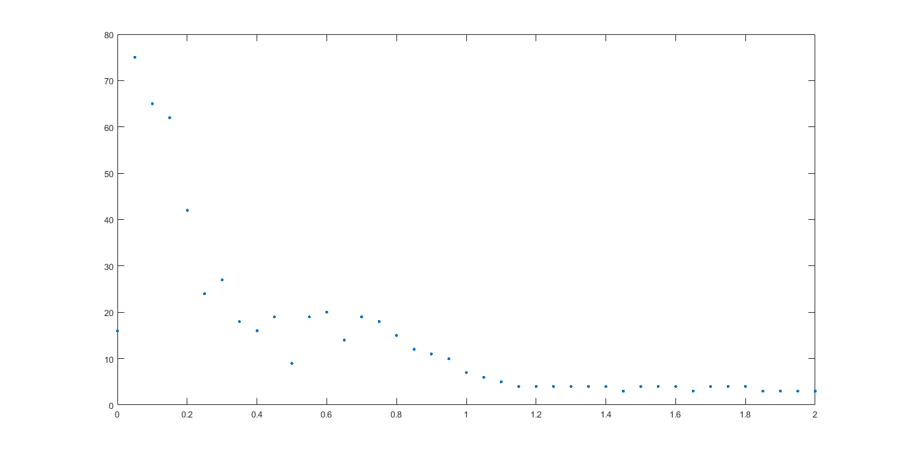

Figure : n = 5000, mu vs iters

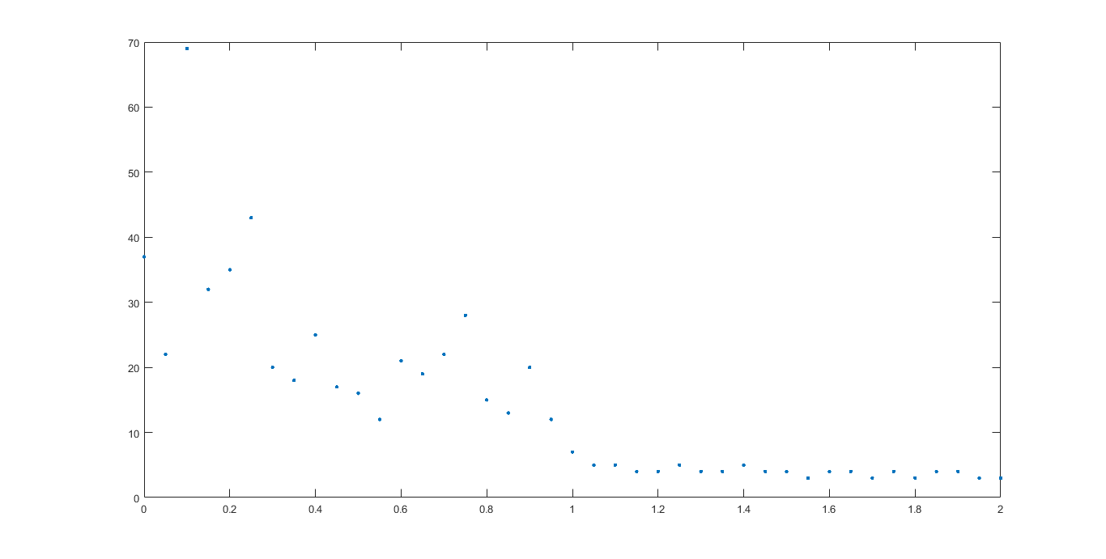

Figure : n = 10000, mu vs iters

**KN - k=2, variable mu and n**

**N = [1000, 5000, 10000]**

**Mu = 0 : 0.1 : 2**

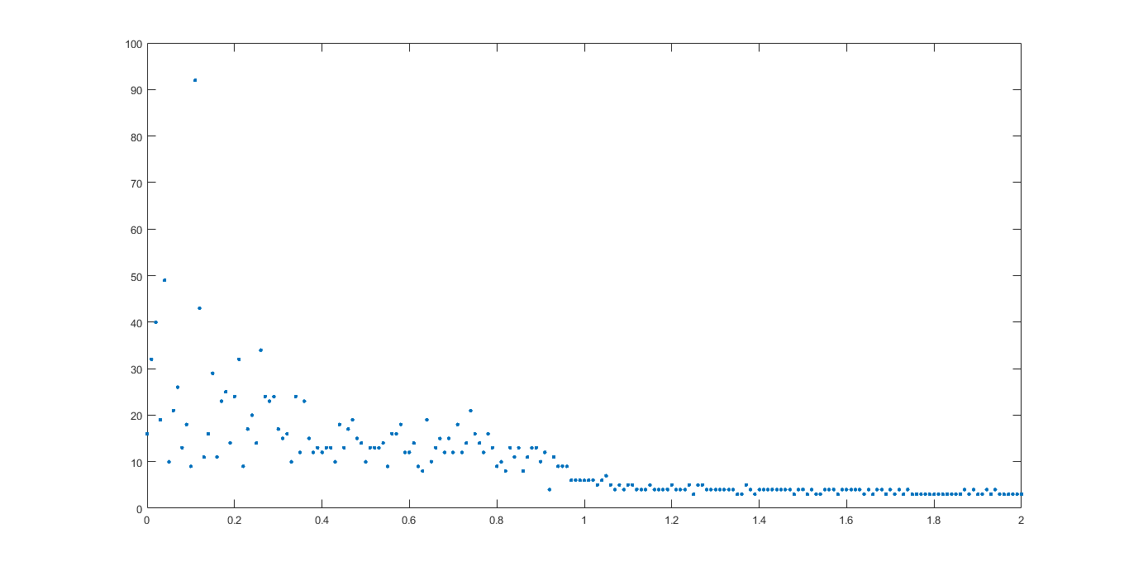

Figure : n = 1000, mu vs iters

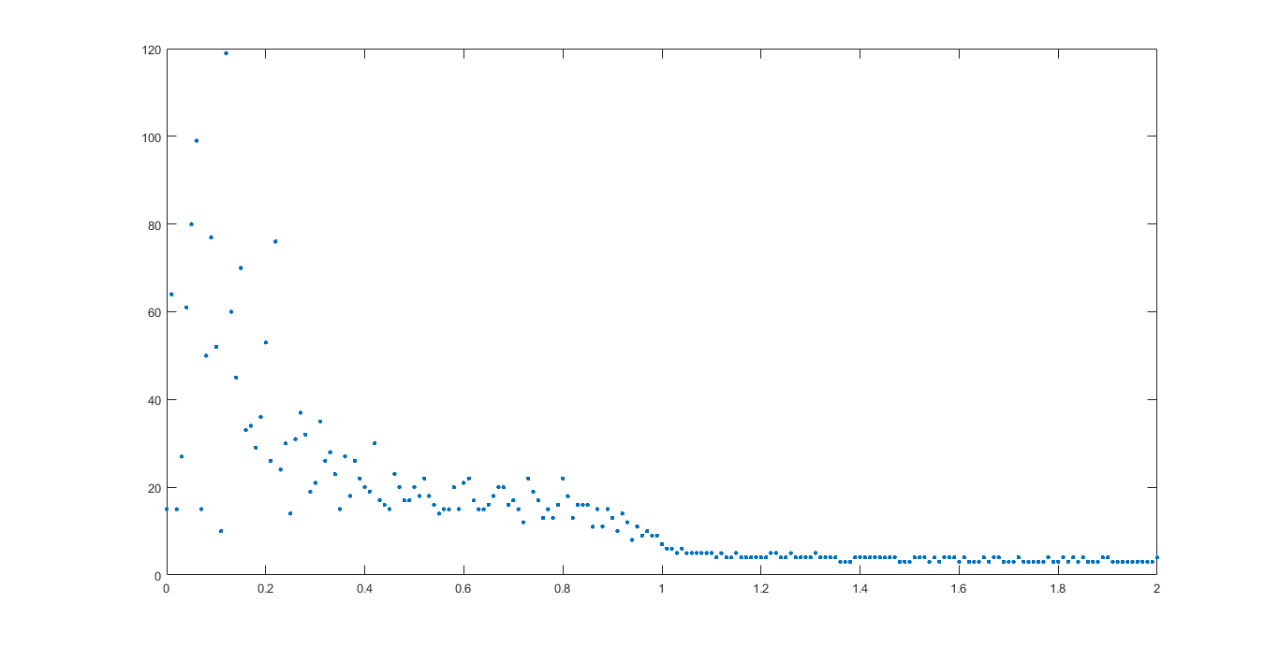

Figure : n = 5000, mu vs iters

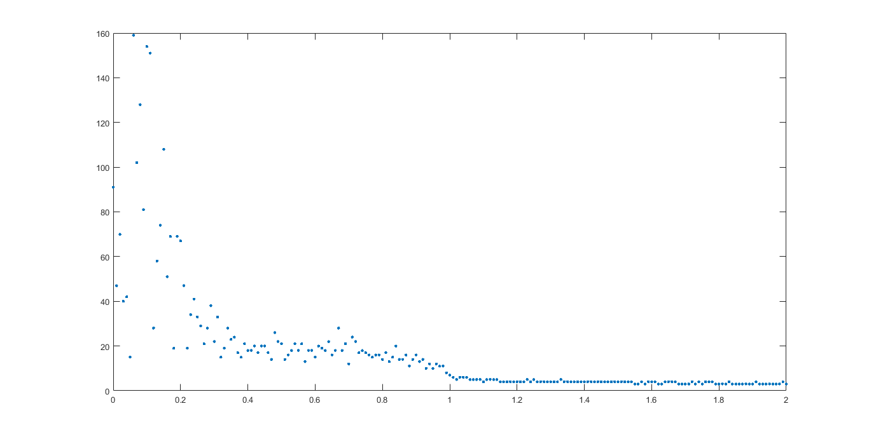

Figure : n = 10000, mu vs iters

**KN - k=2, variable mu and n**

**N = [1000, 5000, 10000]**

**Mu = 0 : 0.01 : 1**

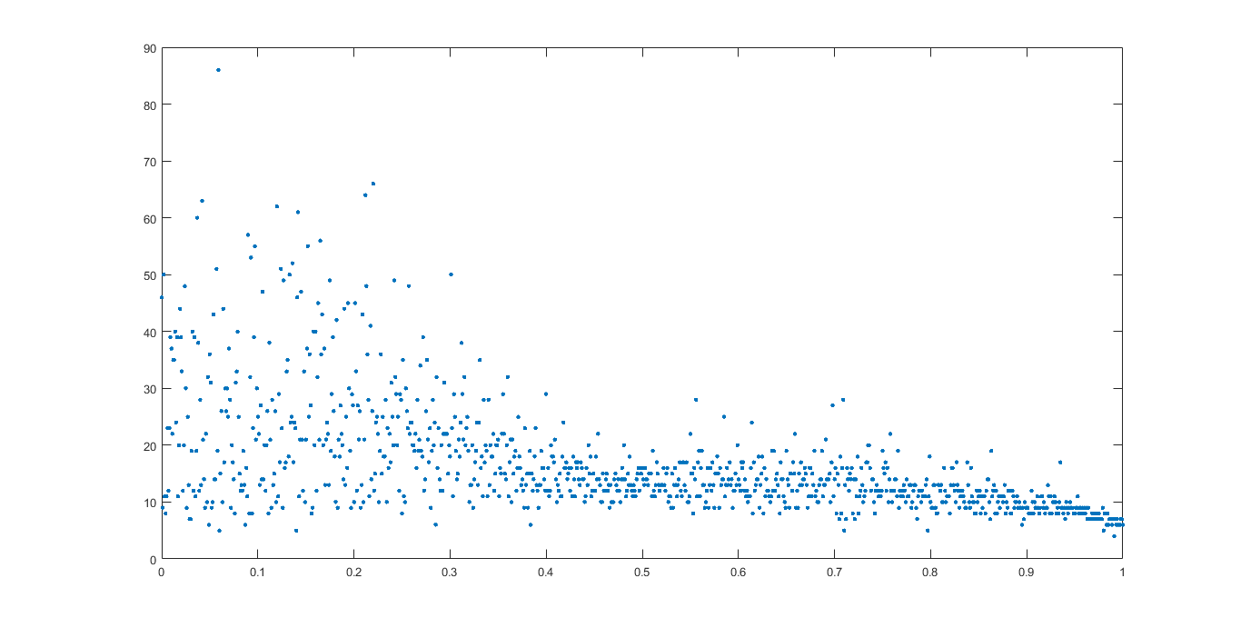

Figure : n = 1000, mu vs iters

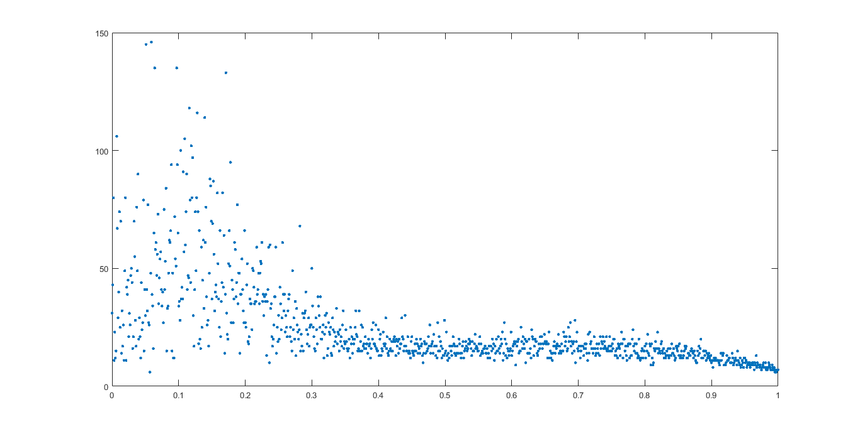

Figure : n = 5000, mu vs iters

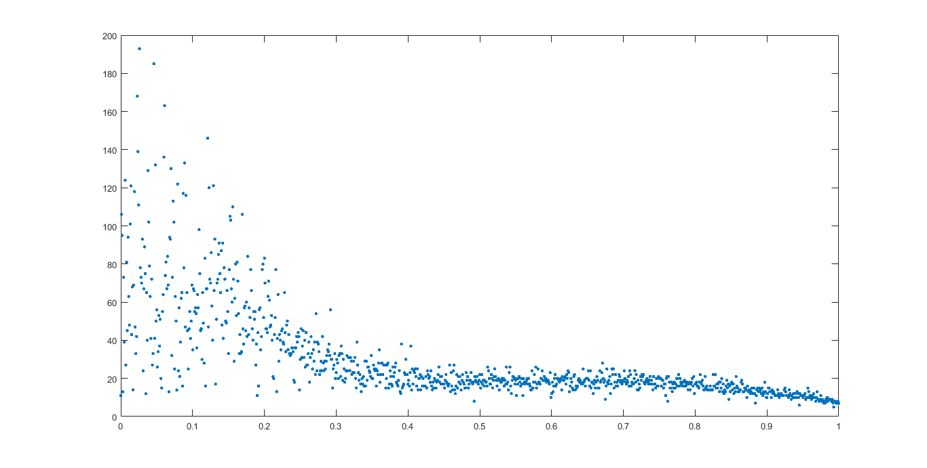

Figure : n = 10000, mu vs iters

**KN - k=2, variable mu and n**

**N = [1000, 5000, 10000]**

**Mu = 0 : 0.005 : 0.3**

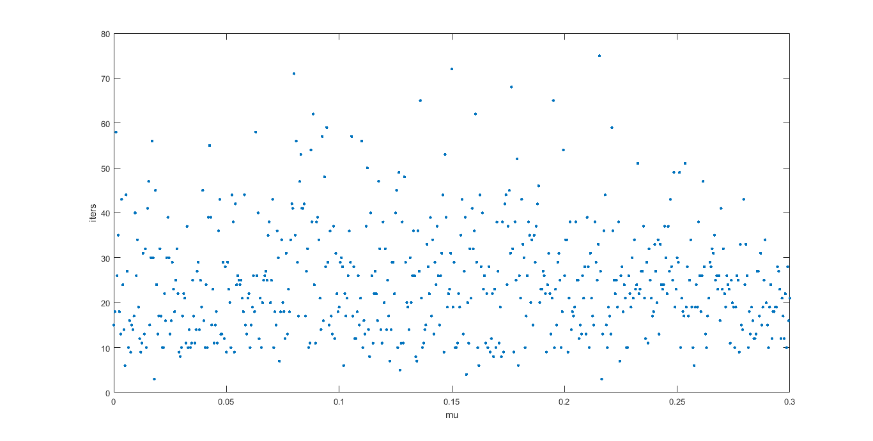

Figure : n = 1000

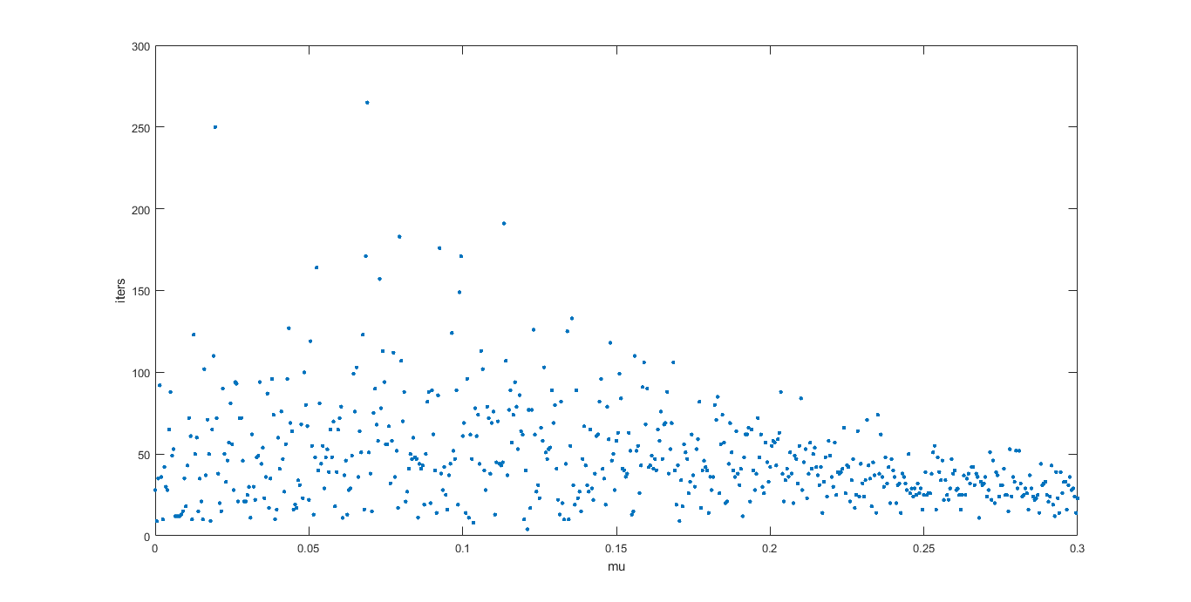

Figure : n = 5000

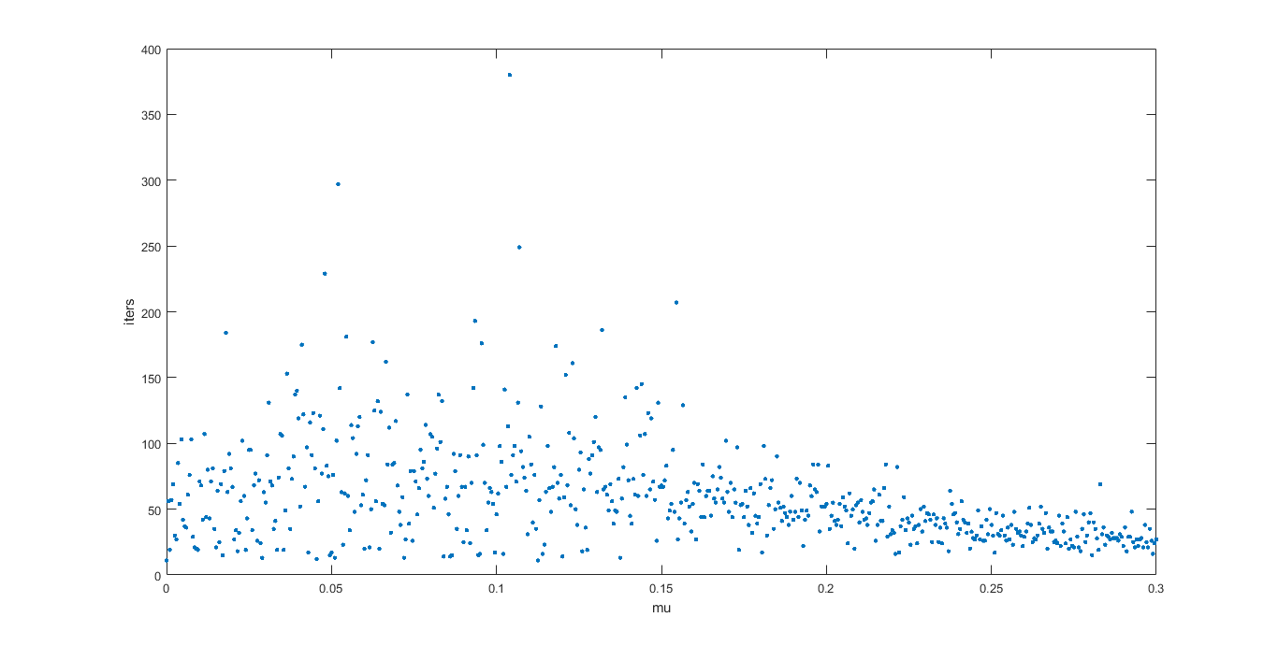

Figure : n = 10000